Assignment 4

Muhammad Umar Salman

Output

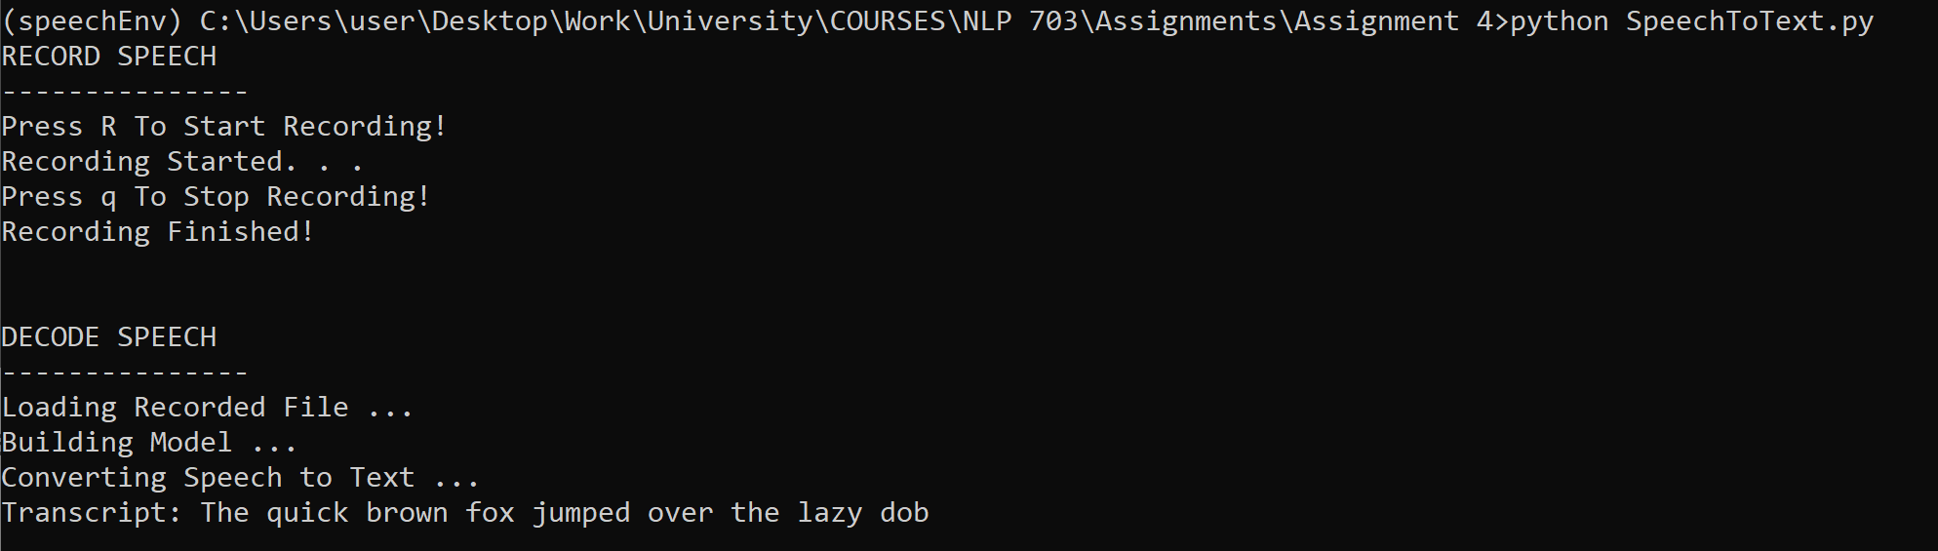

Golden Answer: The quick brown fox jumped over the lazy dog

Code Files

* recordSpeech.py (To record speech)
* SpeechToText.py (Converting speech to text using Wav2Vec model)

Attached Files

* PyAudio wheel file (For windows pyaudio installation)
* Requirements.txt